**Title:** Reddit Examples of Sexual Harassment in STEM

**Type of Activity:** Small group discussion

**Time required:** 10-15 mins.

**Learning Outcome applied:**  Identify and describe the three forms of sexual harassment and recognize them in examples. – Sexual Coercion, Unwanted Sexual Attention, Gender Harassment.

**Overview:** This learning activity uses screenshots from a reddit thread of women in STEM fields describing their experiences with sexual harassment. It asks students to identify forms of sexual harassment and asks them to reflect on their own personal experiences with sexual harassment in STEM. All questions within this activity are suggestions so feel free to skip around or add any questions of your own that come up during your discussion.

**Step 1:** Display to students these real-life examples of sexual harassment in STEM pulled from an online Reddit forum.

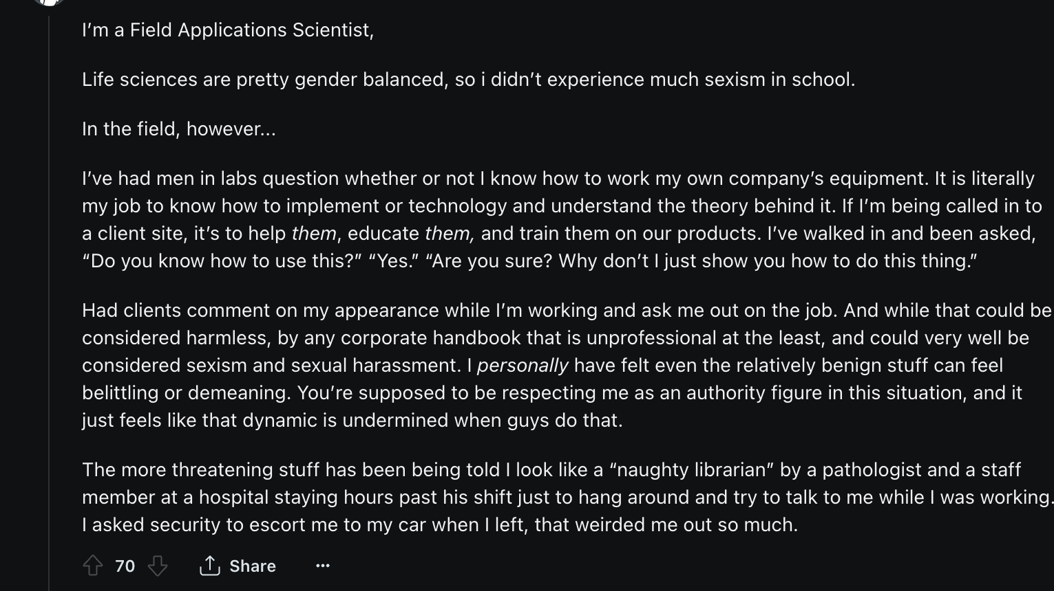

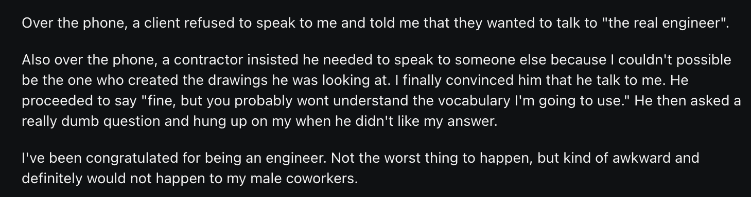

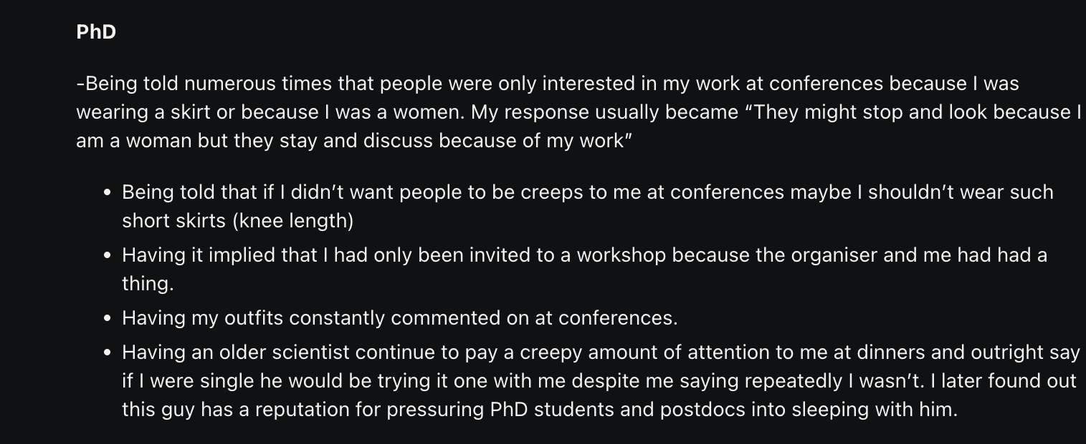

**Step 2:** After all examples are shown, ask students to form groups to reflect on the following questions below in the groups. Have each group elect one student to share out to the class and note each group's thoughts on the board.

1. What forms of sexual harassment are discussed in the examples?
2. Are there any examples shown that have multiple different forms and if so, what are they?

**Step 3:** After all groups have shared and their thoughts are on the whiteboard ask students to answer the following questions in a class discussion

1. Have you ever experienced one of the three forms of sexual harassment as a STEM major or at work? If not, do you know of any friends or family members who have?
2. Are there any scenarios that were shared in these posts that you related to?

**Step 4:** After the discussion - what gems emerged from the discussion? Jot down any insights that the students brought.